Practical -01

Loading and Distinguishing Dependent and Independent parameters

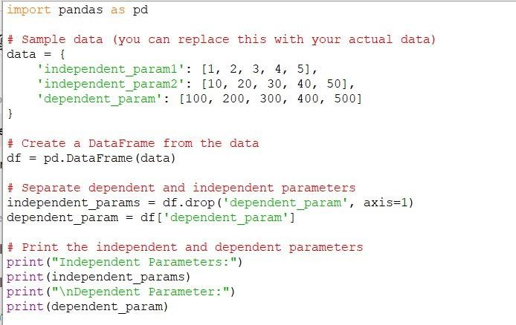Code:

Practical- 02

Exploring Data Visualization tools

1. Matplotlib

Code:

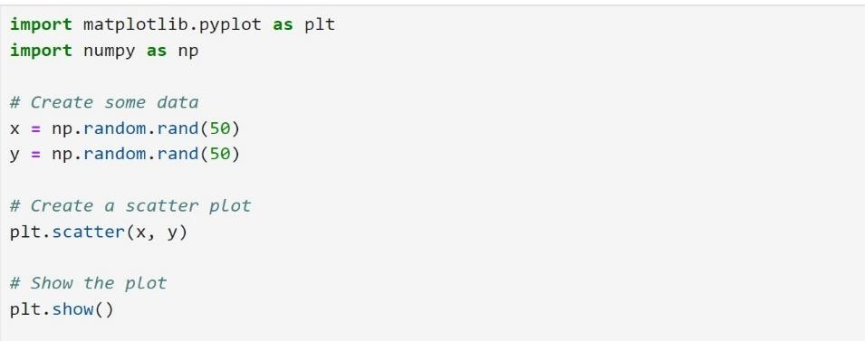

1. **seaborn**

Code:

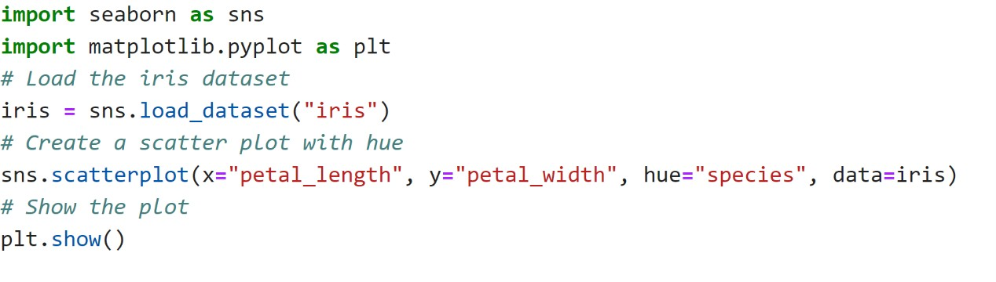

1. Plotly

Code:

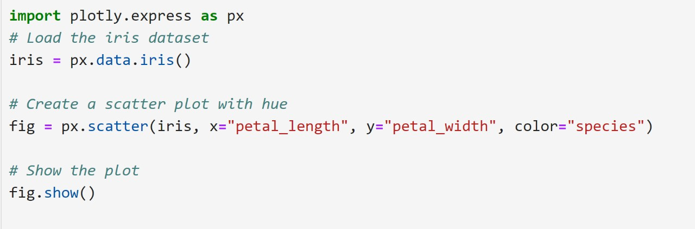

Prac:tical-03

Drawing charts

1. line chart

Code:

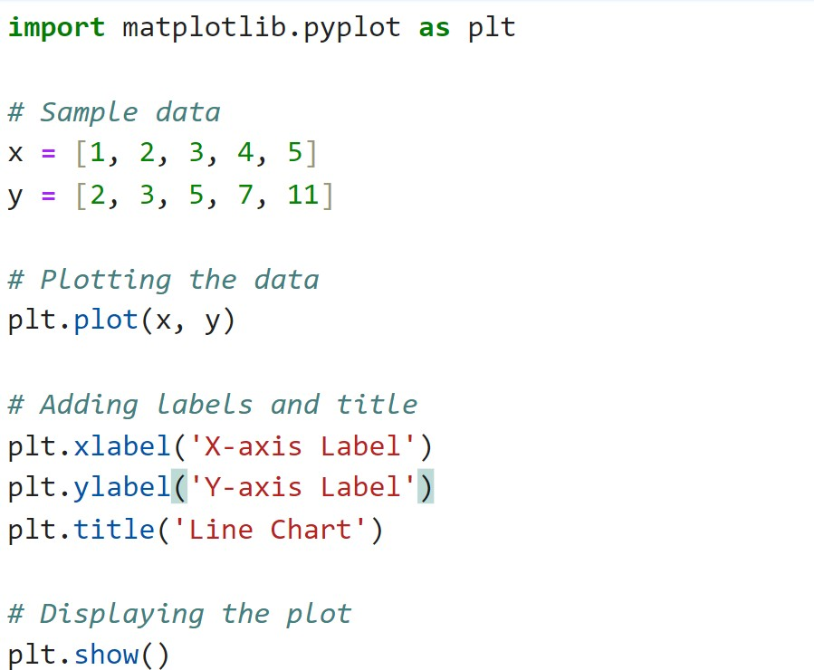

1. Pie chart

Code:

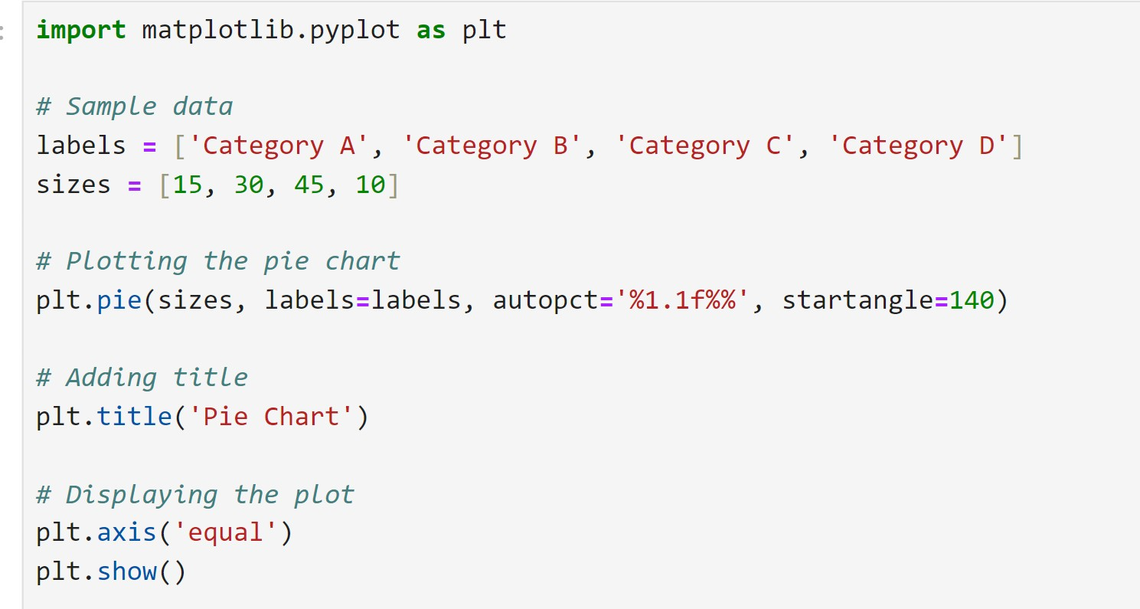

1. Scatter Plot

Code:

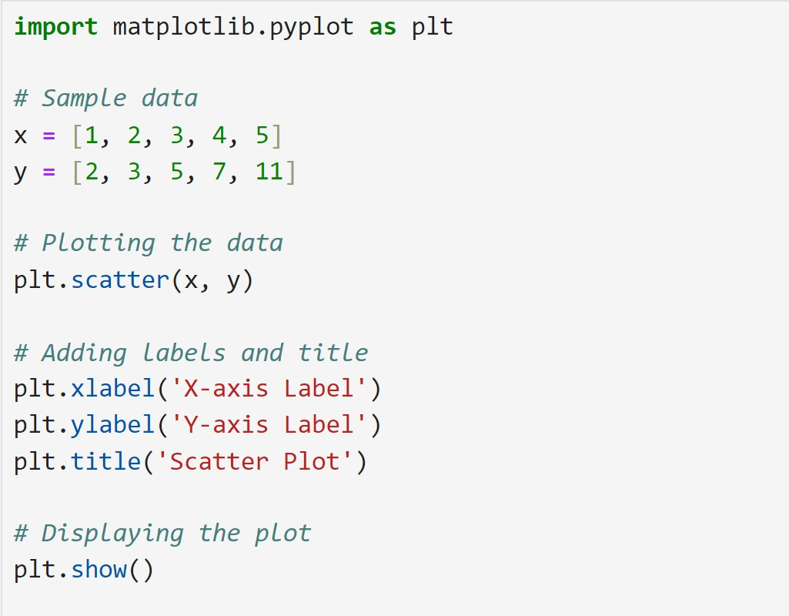

Prac:tical-04

Drawing Graphs

1. Line Graph

Code:

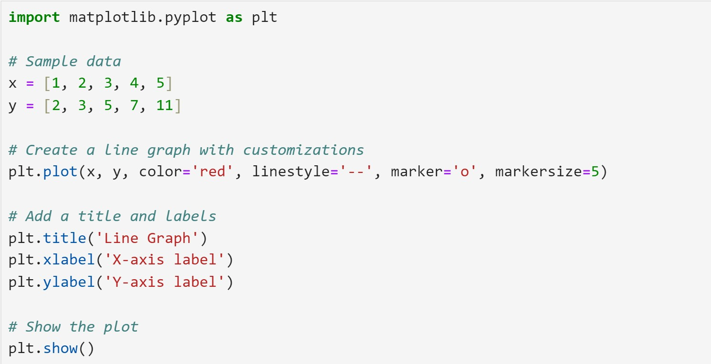

1. Histogram:

Code:

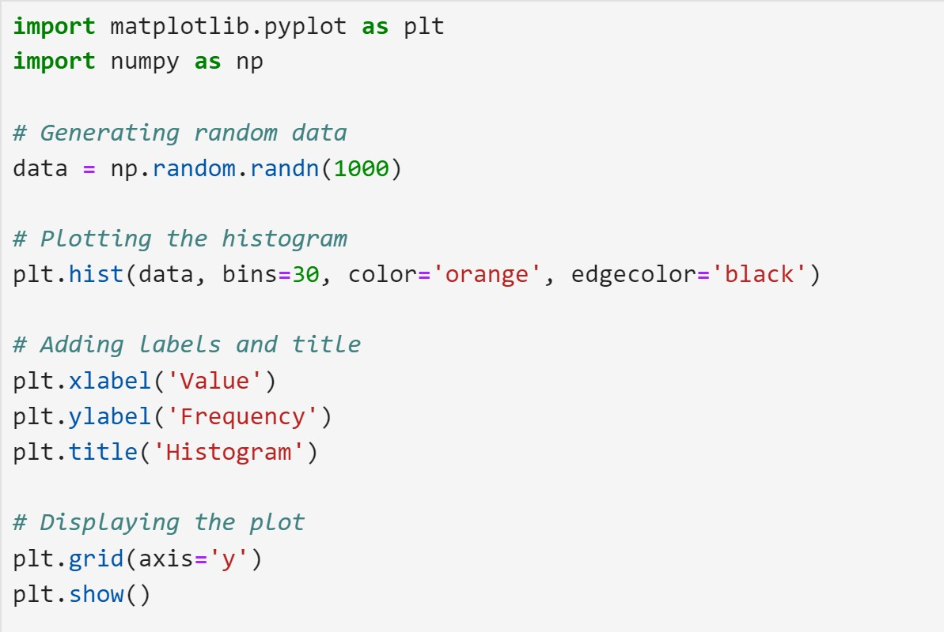

1. Bar Graph

Code:

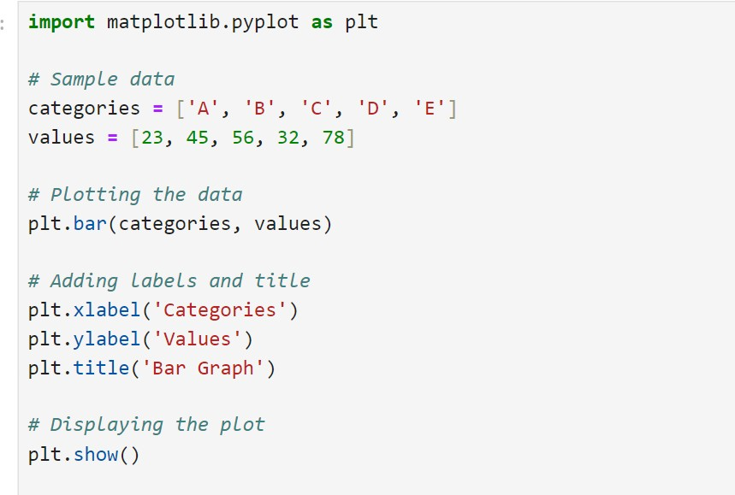

PRACTICAL- 05

Prac 05: data mapping

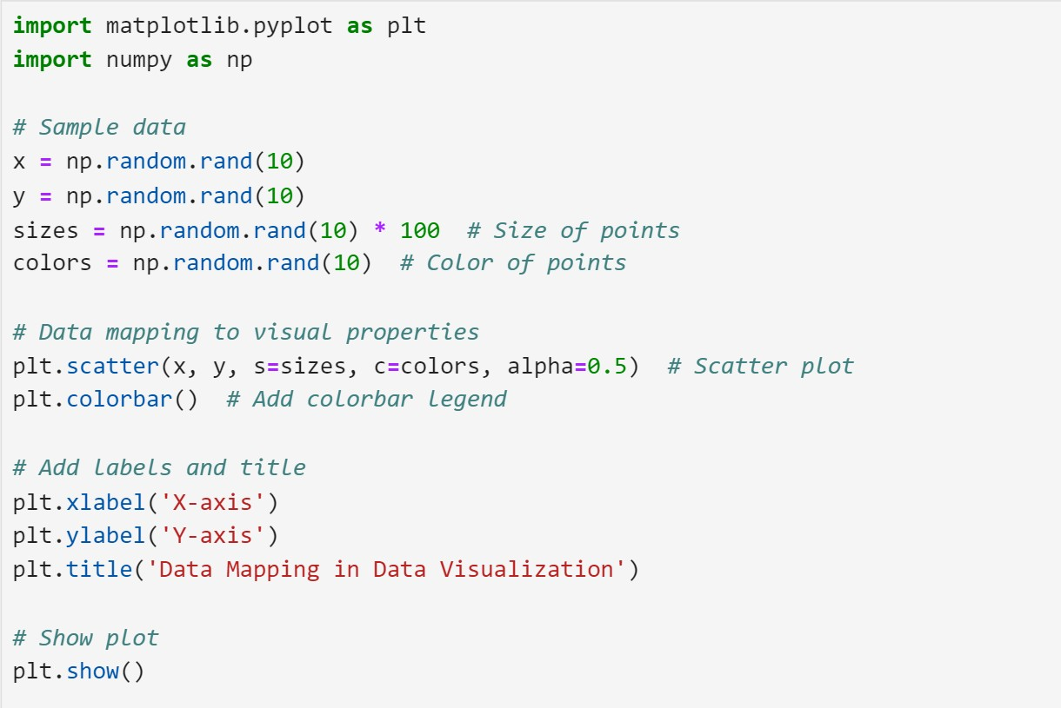Code:

PRACTICAL- 06

Creating Scatter Plot Maps

Code:

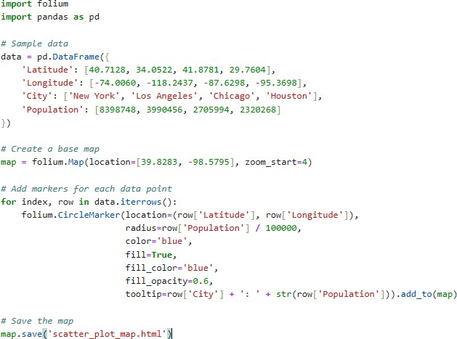

Practical -07 Using BNF Notations

Code:

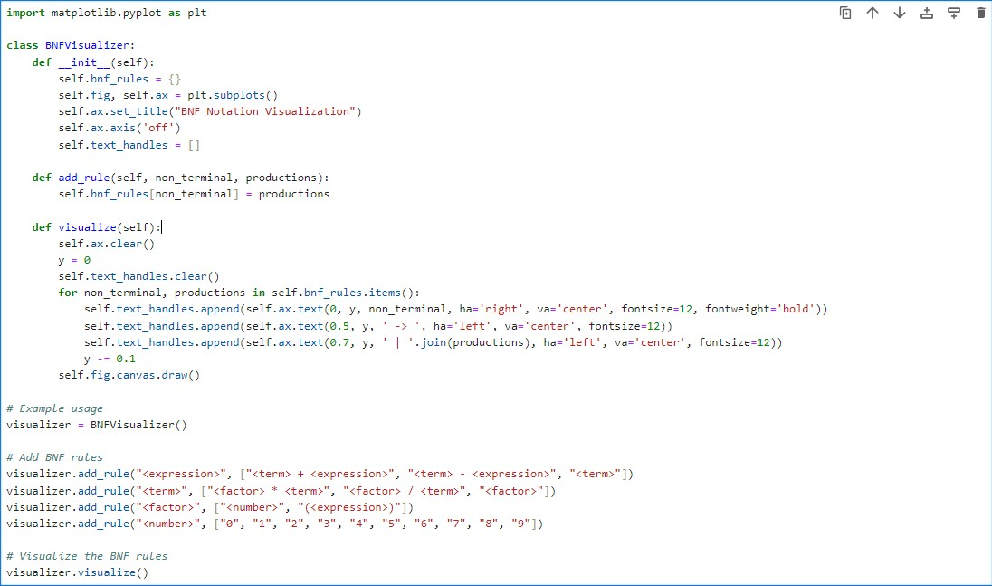

Practical -08

Working with regex

Code:-

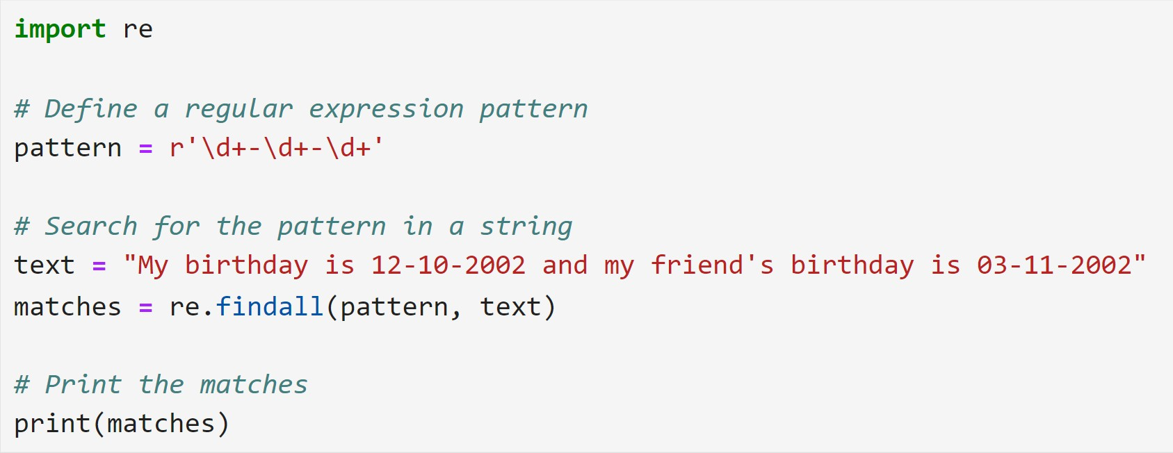

Practical -09

Visualize network data

Code-

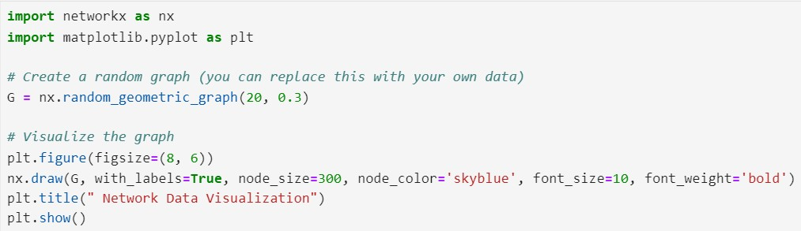

Practical -10

Understanding data visualization frameworks

Code:-

